Food Packaging Materials - Sorted into various groups by Year 6 students
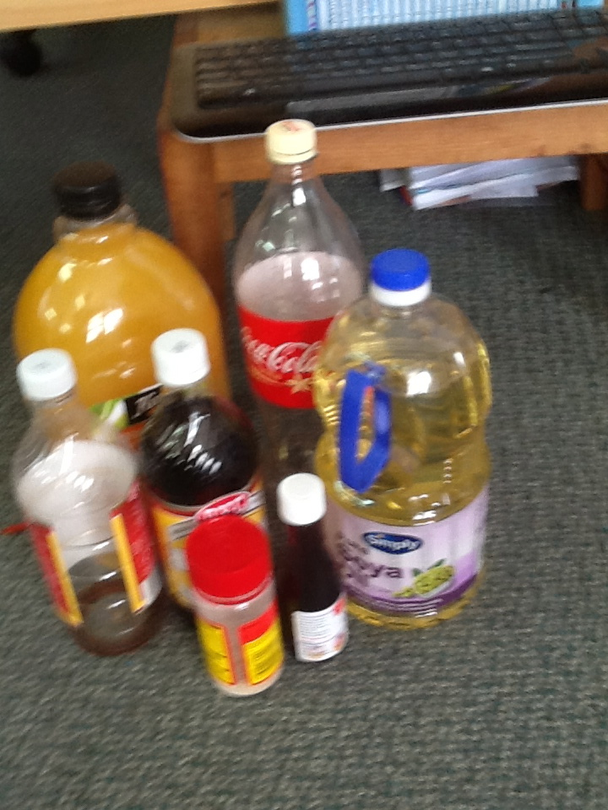
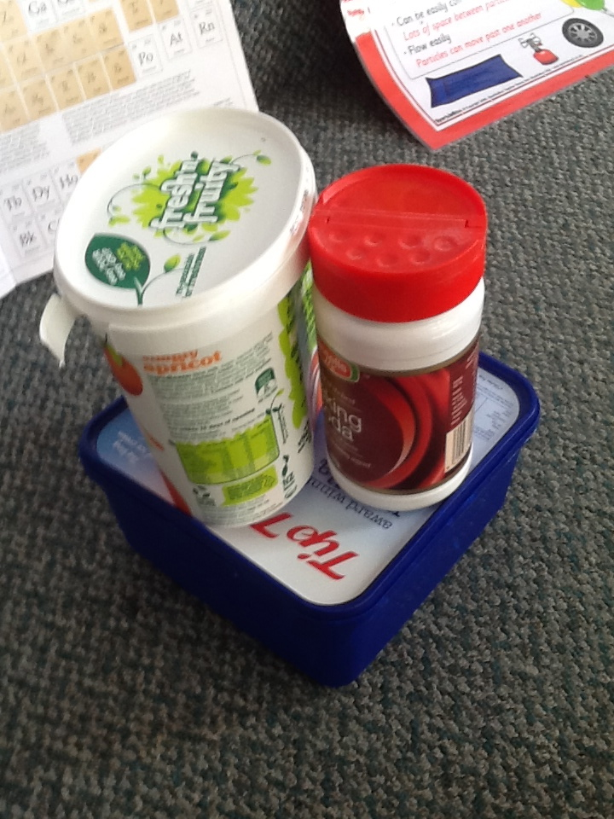
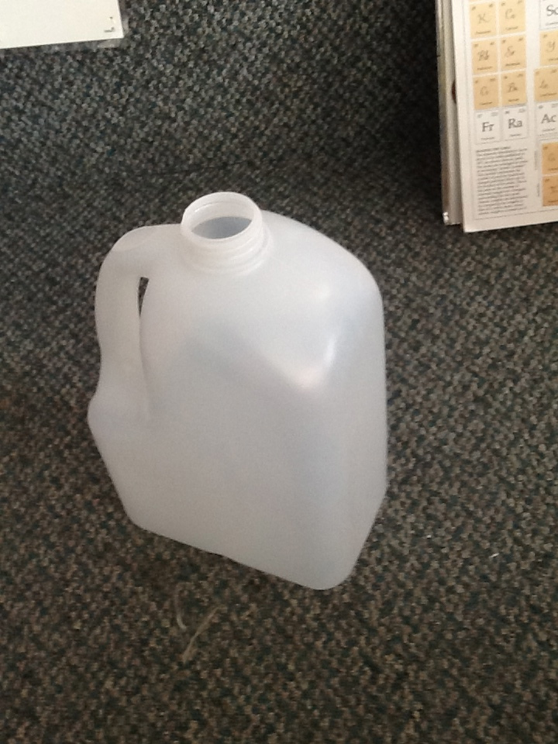
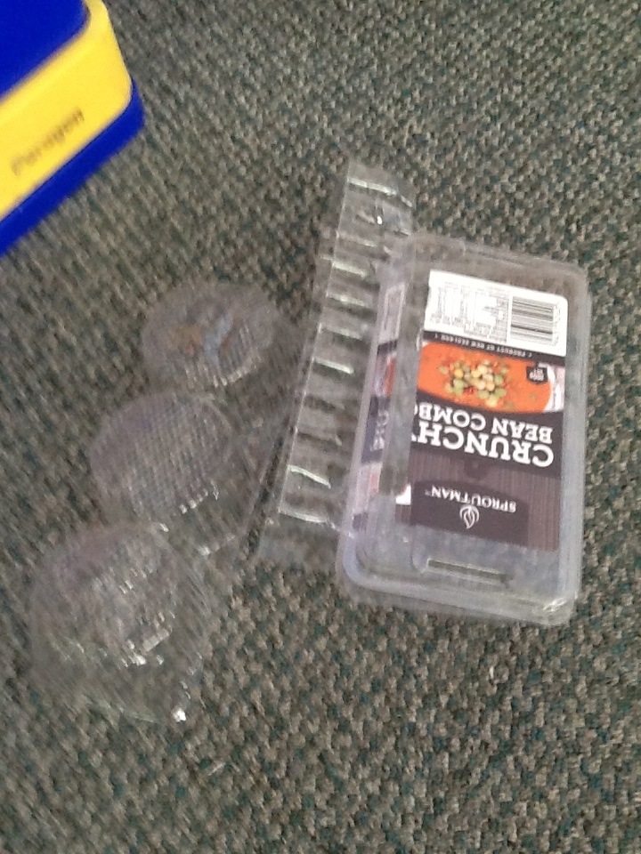

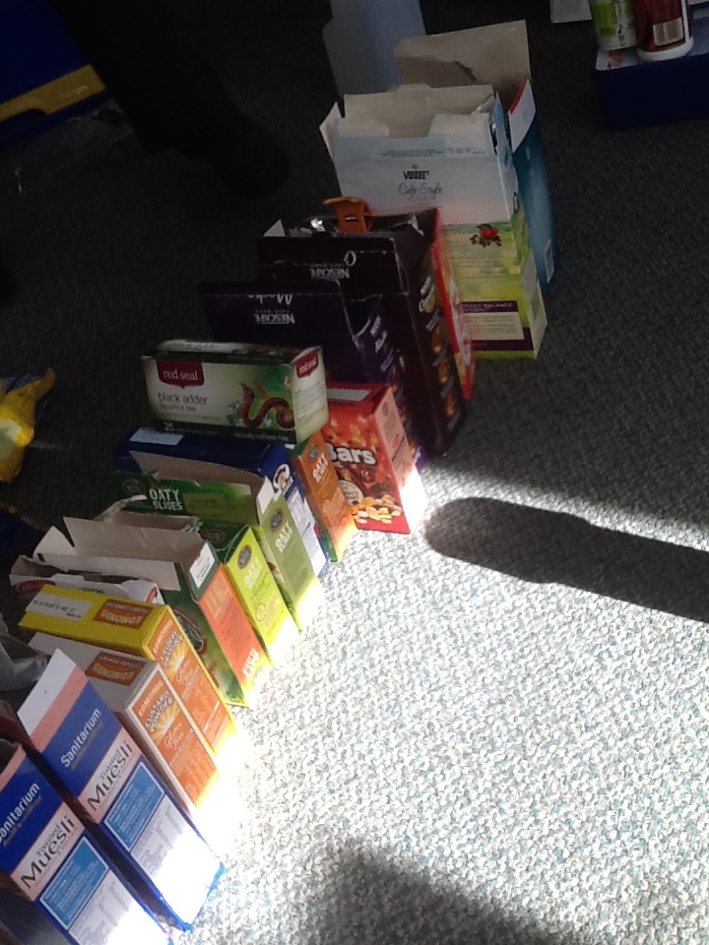
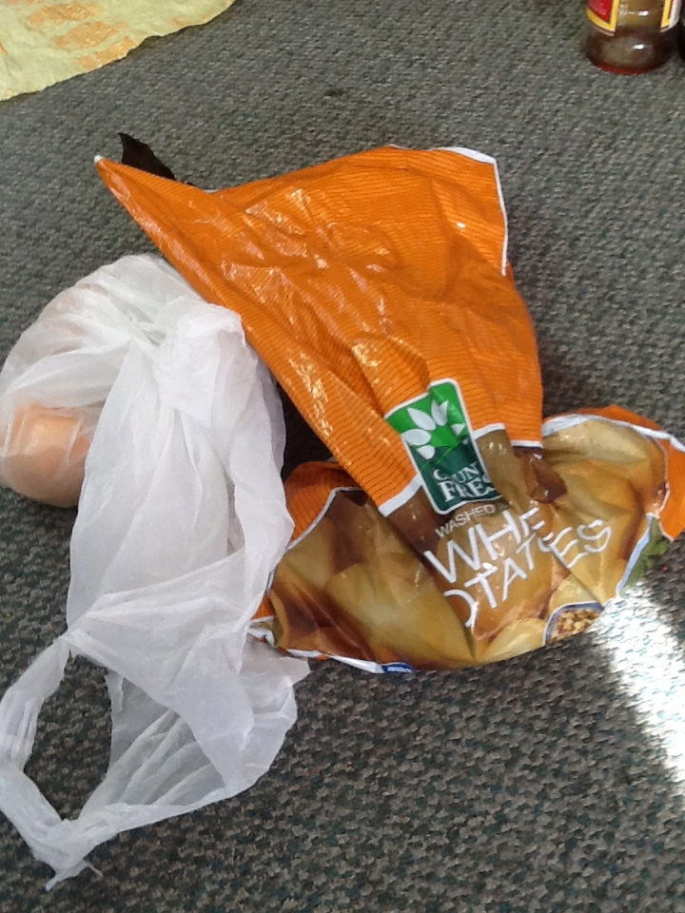
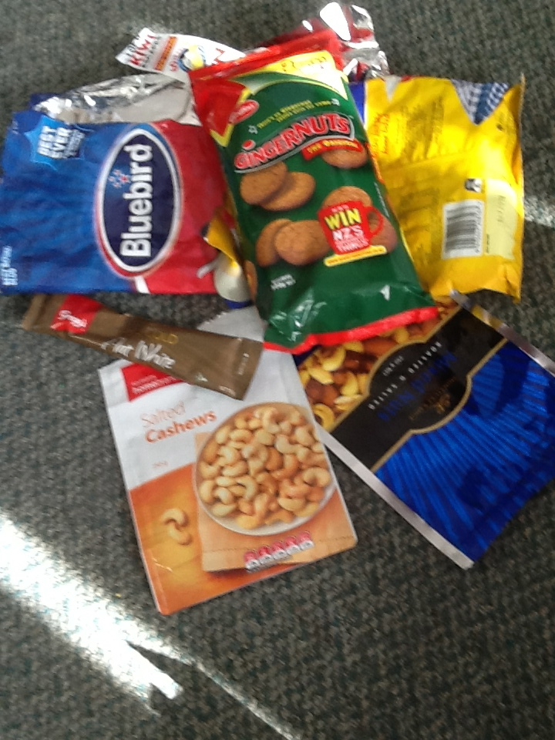
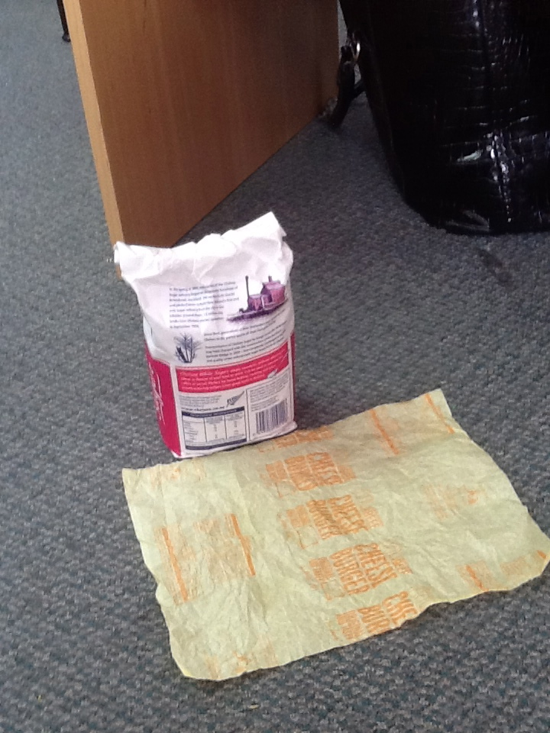
1. .................................... 2. .......................................... 3. ......................................... 4. ..........................................
5. .................................... 6. ......................................... 7. ......................................... 8. ..........................................
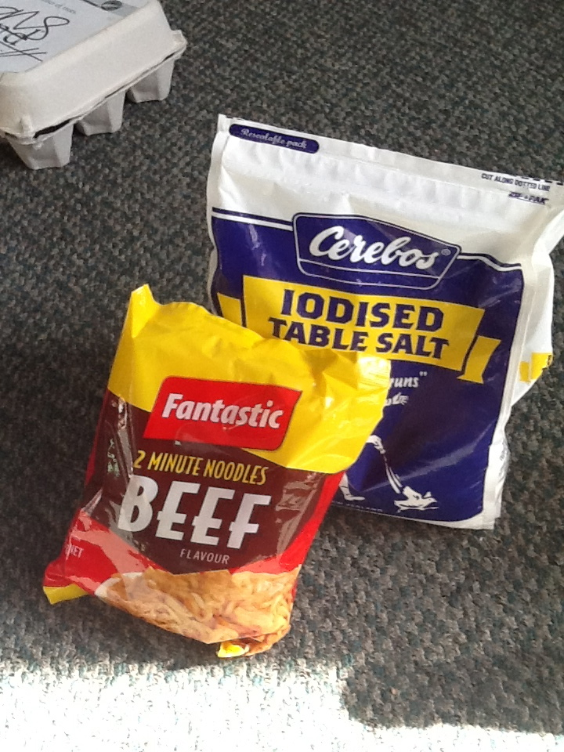
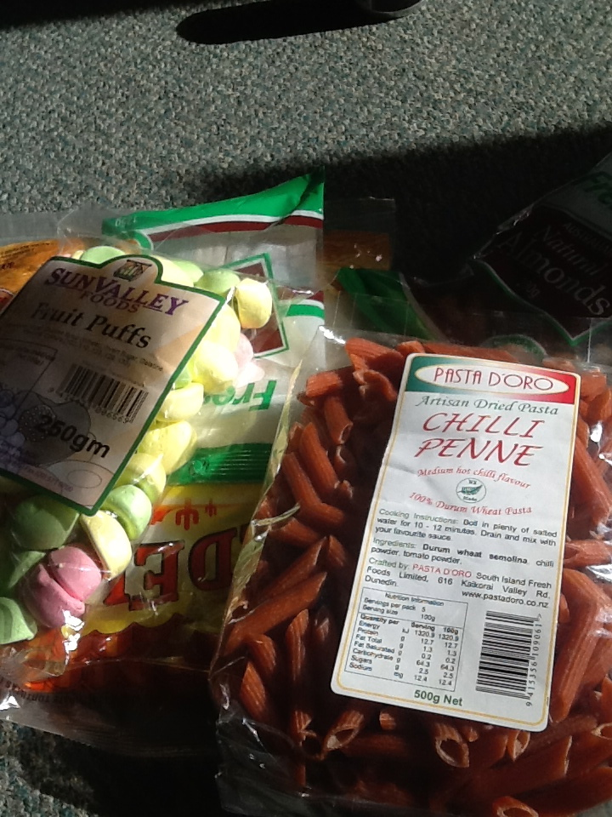
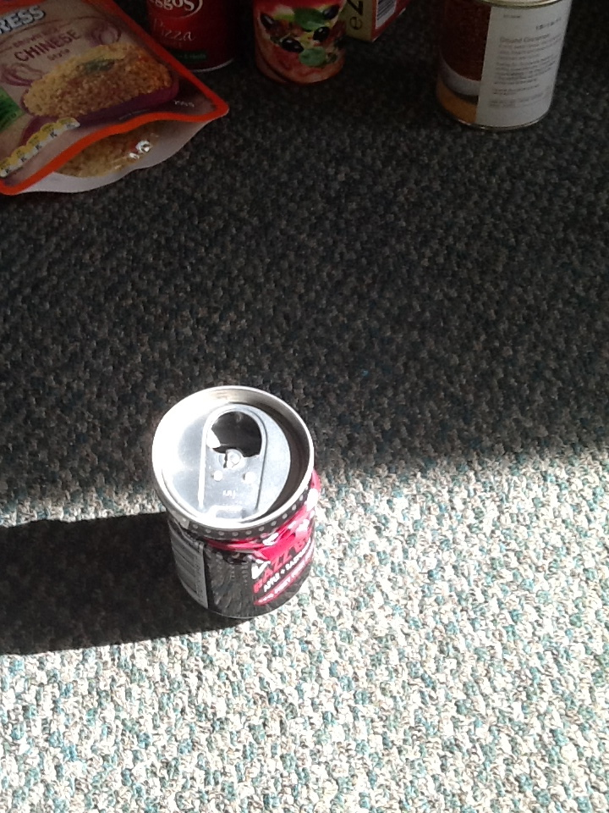
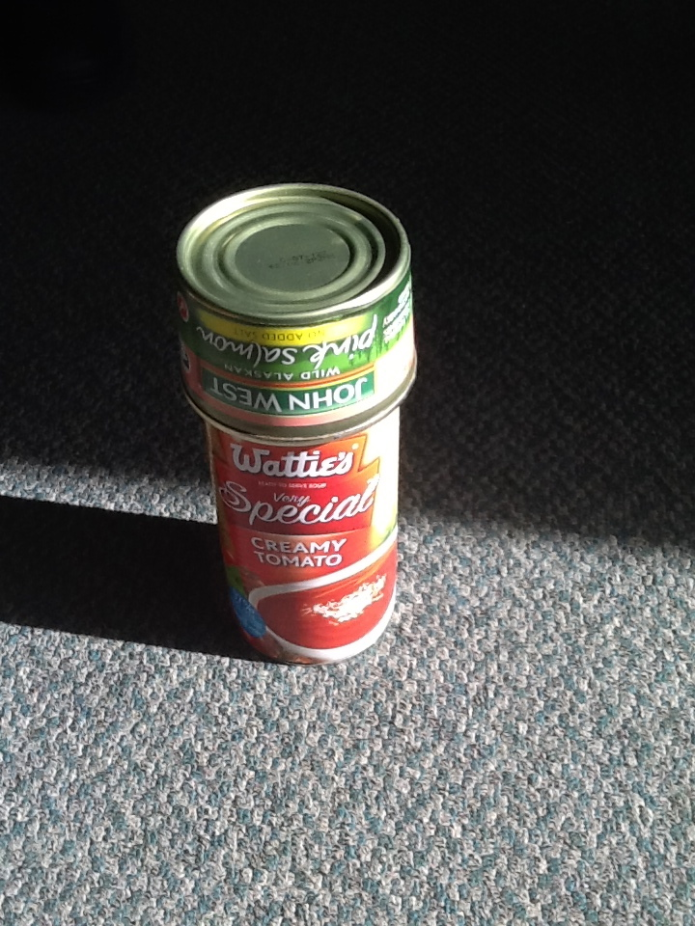

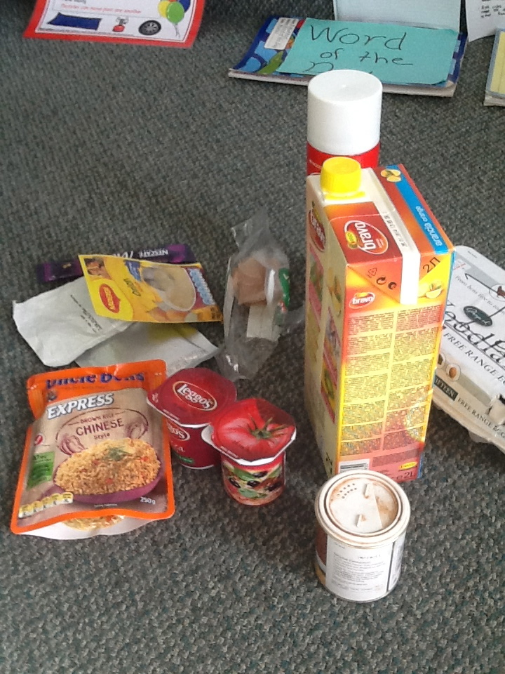
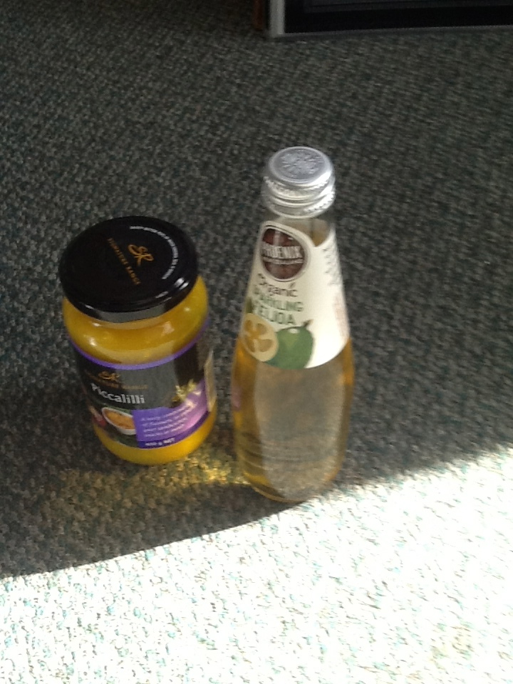
9. ................................... 10. ..................................... 11. ......................................... 12. .....................................
13. ............................... 14. ................................... 15. ......................................

(1) List the properties of the materials in each of these packaging groups?
(2) Identify which properties can be measured (O) objectively or (S) subjectively?
(3) Is this type of packaging technically and socially feasible? Yes or No.

Group 1 ...............................................................................

(1)...................................................................................................................................................................................................

(2)..................................................................................................................................................................................................

(3) .................................................................................................................................................................................................

Group 2 ...............................................................................

(1)...................................................................................................................................................................................................

(2)..................................................................................................................................................................................................

(3) .................................................................................................................................................................................................

Group 3 ...............................................................................

(1)...................................................................................................................................................................................................

(2)..................................................................................................................................................................................................

(3) .................................................................................................................................................................................................

Group 4 ...............................................................................

(1)...................................................................................................................................................................................................

(2)..................................................................................................................................................................................................

(3) .................................................................................................................................................................................................

Group 5 ...............................................................................

(1)...................................................................................................................................................................................................

(2)..................................................................................................................................................................................................

(3) .................................................................................................................................................................................................

Group 6 ...............................................................................

(1)...................................................................................................................................................................................................

(2)..................................................................................................................................................................................................

(3) .................................................................................................................................................................................................

Group 7 ...............................................................................

(1)...................................................................................................................................................................................................

(2)..................................................................................................................................................................................................

(3) .................................................................................................................................................................................................

Group 8 ...............................................................................

(1)...................................................................................................................................................................................................

(2)..................................................................................................................................................................................................

(3) .................................................................................................................................................................................................

Group 9 ...............................................................................

(1)...................................................................................................................................................................................................

(2)..................................................................................................................................................................................................

(3) .................................................................................................................................................................................................

Group 10 ...............................................................................

(1)...................................................................................................................................................................................................

(2)..................................................................................................................................................................................................

(3) .................................................................................................................................................................................................

Group 11 ..............................................................................

(1)...................................................................................................................................................................................................

(2)..................................................................................................................................................................................................

(3) .................................................................................................................................................................................................

Group 12 ...............................................................................

(1)...................................................................................................................................................................................................

(2)..................................................................................................................................................................................................

(3) .................................................................................................................................................................................................

Group 13 ...............................................................................

(1)...................................................................................................................................................................................................

(2)..................................................................................................................................................................................................

(3) .................................................................................................................................................................................................

Group 14 ...............................................................................

(1)...................................................................................................................................................................................................

(2)..................................................................................................................................................................................................

(3) .................................................................................................................................................................................................

Group 15 ...............................................................................

(1)...................................................................................................................................................................................................

(2)..................................................................................................................................................................................................

(3) .................................................................................................................................................................................................

Label the packaging of a food product at home.

Name ..................................................................................

Draw or copy and paste a picture of a food product and attach it to the centre of the page.

Label all the materials that you can identify on the food packaging.

List the properties of each material underneath it.

Write (O) or (S) beside each material to say whether or not you can measure the properties Objectiely or Subjectively.

State Yes or No as to whether or not you believe the packaging to be technically and socially feasible and explain why in a short statement.

.........................................................................................................................................................................................................

.........................................................................................................................................................................................................

